Genetic Algorithms
Section #5
Vehicle Routing Problem (VRP)
Imagine that you now manage a larger fulfillment center. You still need to deliver packages to a list of customers, but now you have a fleet of several vehicles at your disposal. What is the best way to deliver the packages to the customers using these vehicles?
This is an example of VRP, a generalization of the TSP described in the previous section. The basic VRP consists of the following three components:
- The list of locations that need to be visited.
- The number of vehicles.
- The location of the depot, which is used as the starting and ending point for each one of the vehicles.
Note :- Instead of one vehicle, we have multiple vehicles delivering to customers.

Goal
Minimize:
- total distance
- or total cost
- or delivery time

Real Scenario
You have:
- A warehouse (depot)
- Many customers
- Multiple delivery vehicles
Each vehicle:
- starts from depot
- visits some customers
- returns to depot
An illustration of a VRP with three vehicles is shown here. The cities are marked with dark circles and the depot location is marked with an empty square, while the routes of the three vehicles are marked with three different colors:
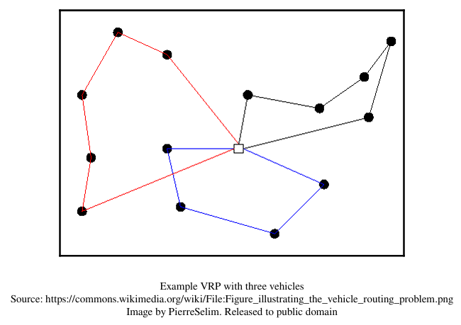
Problem Components:-
  - Customers (Locations)
Set of nodes:
C={1,2,3,...,n}C = \{1,2,3,...,n\}C={1,2,3,...,n}
Each has coordinates:
Customer 1 → (x1, y1)
Customer 2 → (x2, y2)

Depot
Single node:
Depot → (x0, y0)

Vehicles
k=number of vehicles (Each vehicle handles a subset of customers).

Example :-

Suppose:
- Depot: (0,0)
- Customers:
1 → (2,3)
2 → (5,4)
3 → (1,7)
4 → (6,8)
5 → (3,6)
- Vehicles = 2

Possible Solution:
Vehicle 1:
Depot → 1 → 3 → 5 → Depot
Vehicle 2:
Depot → 2 → 4 → Depot

Objective Function (Fitness)
We minimize: 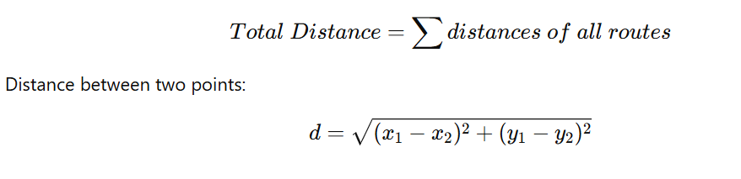

Genetic Algorithm Representation

Genotype (Chromosome)
We encode:
[1, 3, 5 | 2, 4]
  - “|” separates vehicles
Phenotype
Actual routes:
Route1: Depot → 1 → 3 → 5 → Depot
Route2: Depot → 2 → 4 → Depot

Fitness Function
(we minimize distance → maximize fitness)
